FIRST VIOLIN:

Mozart Symphony no. 39

* Movement 2, Beginning to 2nd repeat (don’t take repeats)

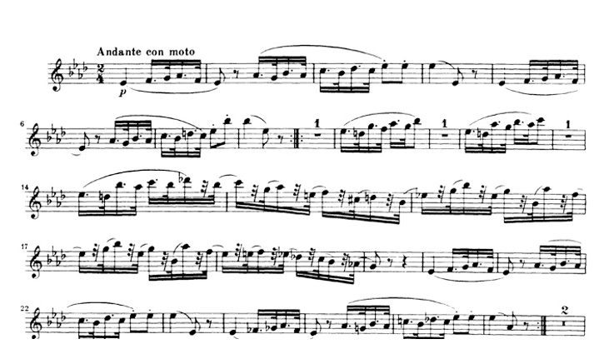



Mozart Symphony no. 39

* Movement 4, Beginning to reh. “B” (m. 78 downbeat)

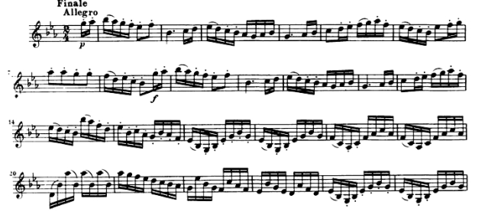



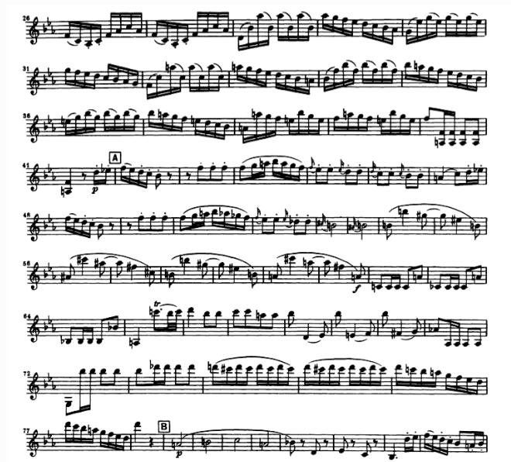



FIRST VIOLIN:

Mendelssohn scherzo from Midsummer Night’s Dream

* m. 17 – m. 99

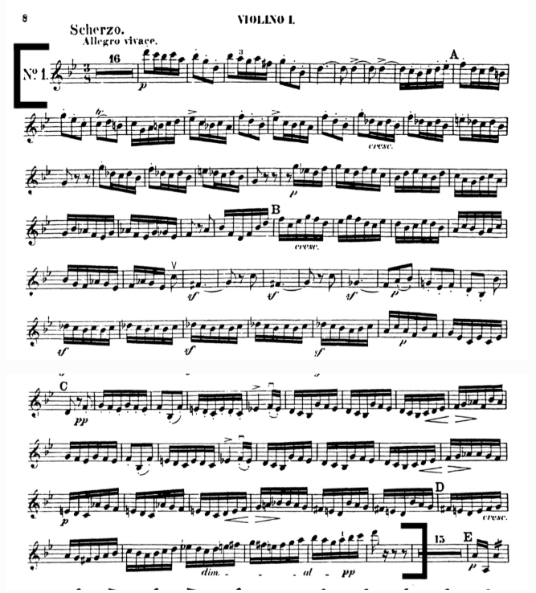

FIRST VIOLIN:

Prokofiev Romeo and Juliet

* Dance of the Knights, 3 after reh. “2” to reh. “5”

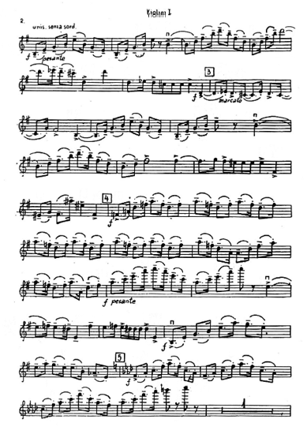



Second Violin Parts:

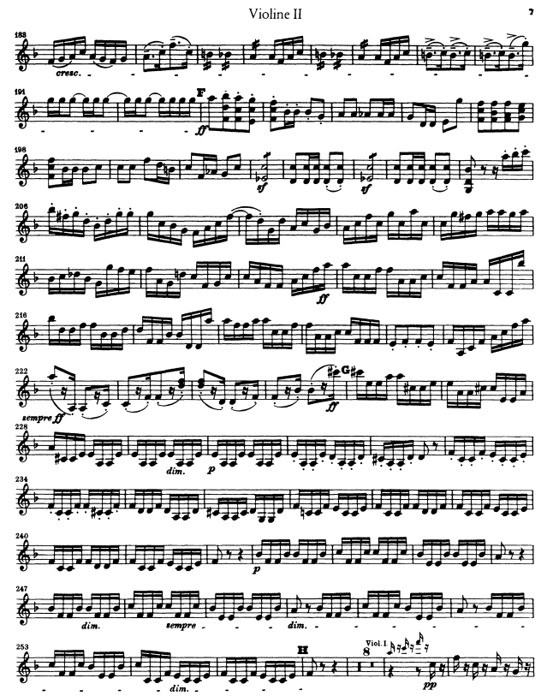 Mendelssohn Symphony no. 3 “Scottish”



SECOND VIOLIN

Beethoven Symphony no. 6 “Pastoral”

-

MVT IV (

“

Donner. Sturm

”

)

, beginning through

19

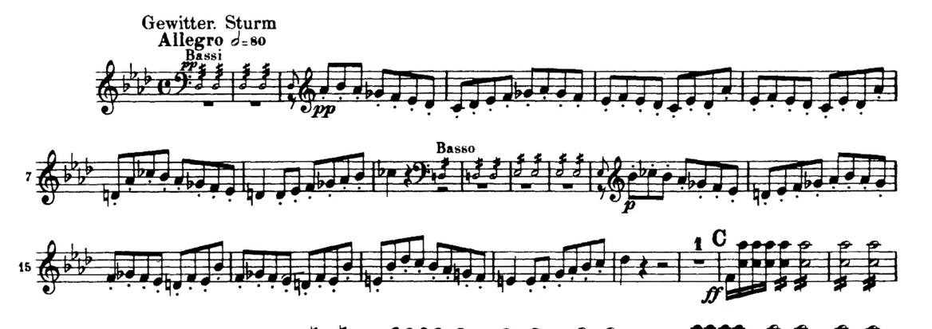

SECOND VIOLIN

Mozart Symphony no. 41

- Mvt IV, beginning through m.157

Mozart Symphony no. 41 (cont)

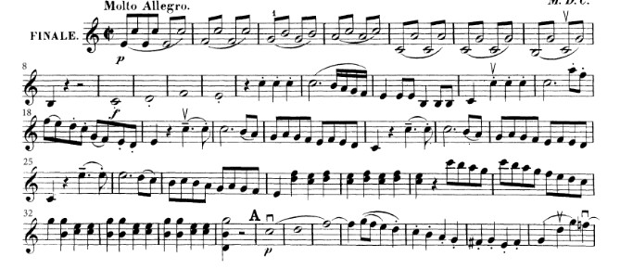

-

Mvt IV, beginning through m.157

