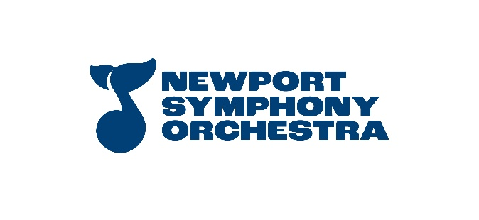Newport Symphony Orchestra is the only professional symphony on the Oregon coast. The ensemble includes musicians from the coast, Eugene, Portland, Salem and beyond. Home base for the orchestra is the 400-seat Newport Performing Arts Center, just steps away from the gorgeous Oregon seashore in historic Nye Beach. Newport Symphony Orchestra is under the direction of Music Director and Conductor Adam Flatt.

**Newport Symphony Orchestra**

**Section Viola**

**SOLO:**

Solo of Candidates choice from standard repertoire:

Mvt. 1 - Exposition

**EXCERPTS:**

Enesco – Romanian Rhapsody No. 1

2nd measure of Rehearsal 7 to Rehearsal 8

Brahms – Variations on a Theme by Haydn

Variation V – Vivace

Variation VII – Grazioso (no repeats)

Variation VIII – Presto non troppo (8 bars, stop at key change)

Mozart – Symphony No. 35

Finale – Presto to Letter A

Finale - m.134 to m.181 (before Rehearsal E)

Shostakovich – Symphony No. 5

Mvt. 1 – 3rd measure of Rehearsal [22] through 1st measure of Rehearsal [24]

**Enesco – Romanian Rhapsody No. 1**

Romanian Rhapsody No. 1 (2nd measure of Rehearsal 7 to Rehearsal 8)

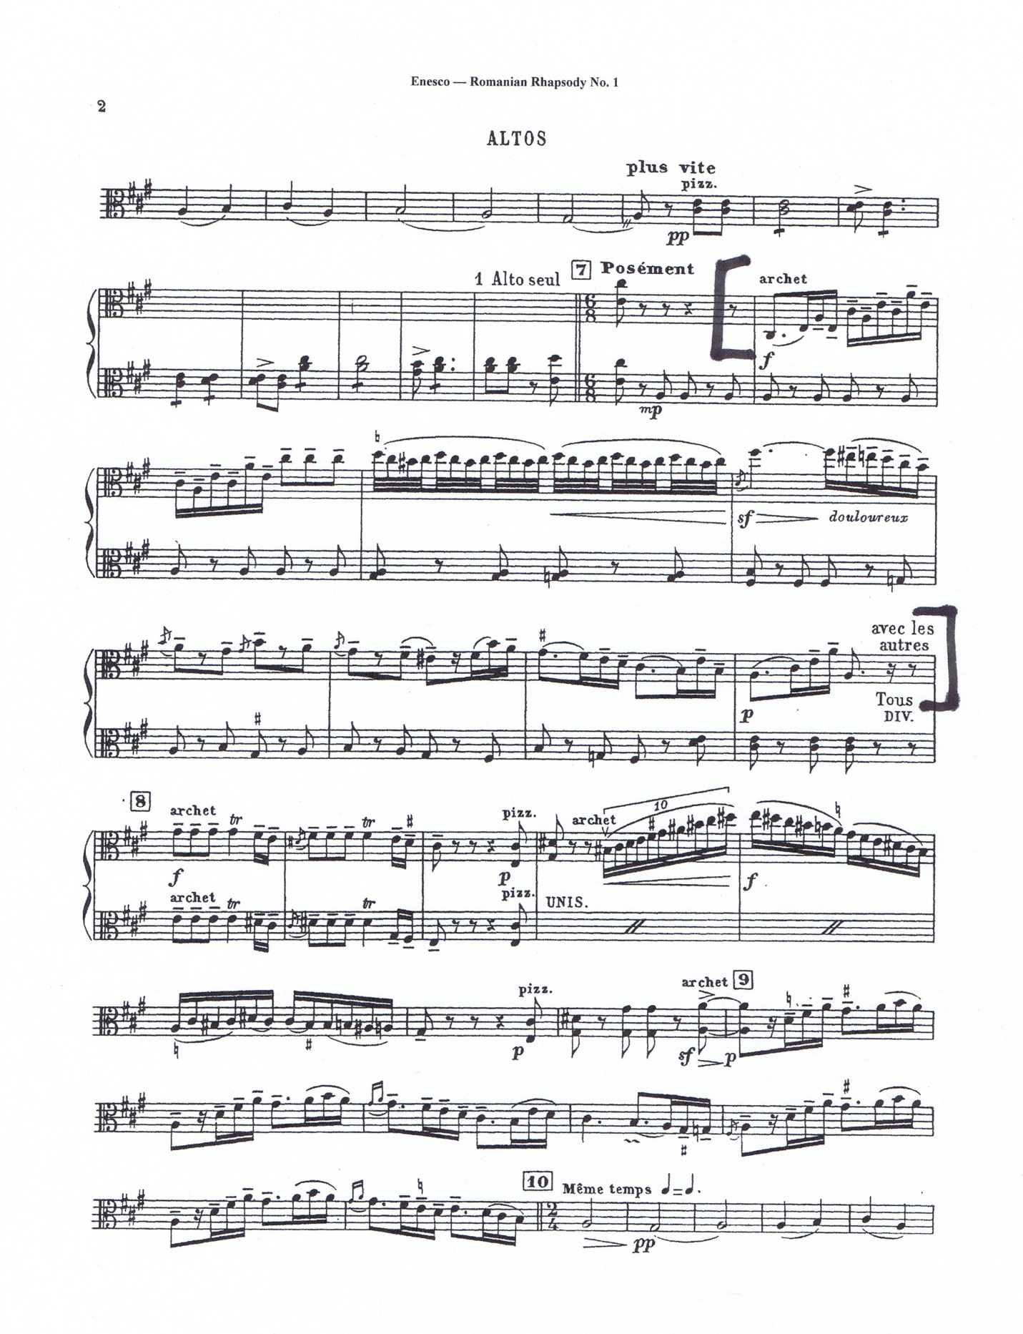

**Brahms – Variation on a Theme by Haydn**

Variation V – Vivace

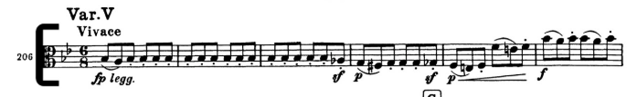

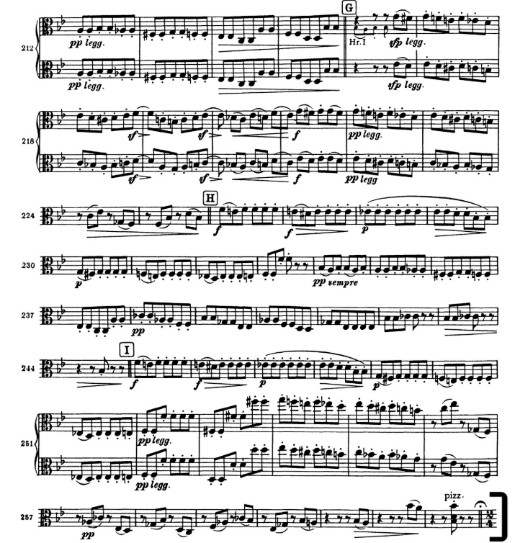

**Brahms – Variation on a Theme by Haydn**

Variation VII – Grazioso (no repeats)

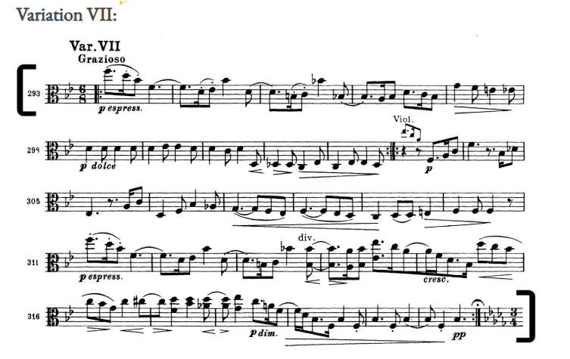

Variation VIII – Presto non troppo (8 bars, stop at key change)

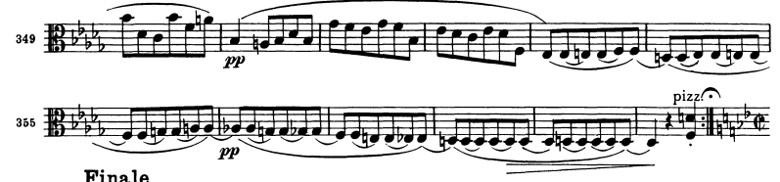

**Mozart – Symphony No. 35**

Finale – Presto to Letter A

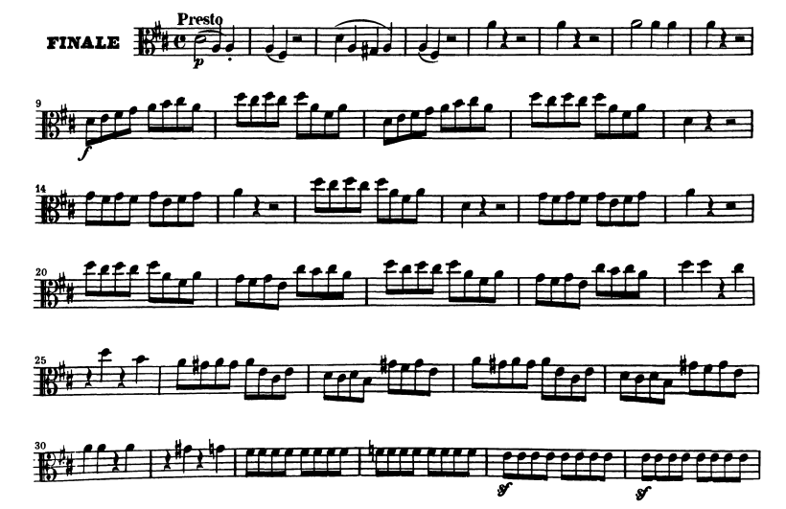

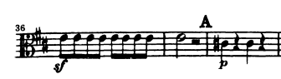

**Mozart – Symphony No. 35**

Finale – m. 134 to m. 181 (before Rehearsal E)

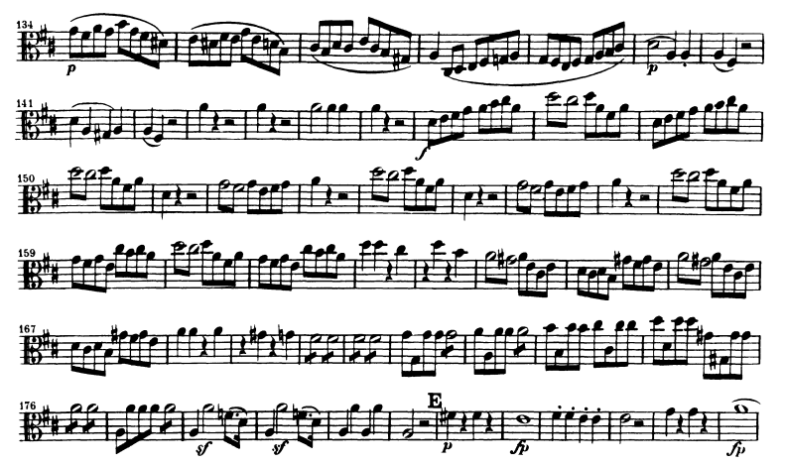

**Shostakovich – Symphony No. 5**

Mvt. 1 – 3rd measure of Rehearsal 22 through 1st measure of Rehearsal 24

