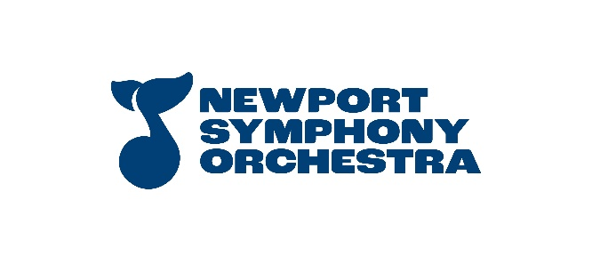 Newport Symphony Orchestra is the only professional symphony on the Oregon coast. The ensemble includes musicians from the coast, Eugene, Portland, Salem and

beyond. Home base for the orchestra is the 400-seat Newport Performing Arts Center, just steps away from the gorgeous Oregon seashore in historic Nye Beach. Newport Symphony Orchestra is under the direction of Music Director and Conductor Adam Flatt.

**Section Violin**

Standard concerto of applicant's choice (first movement, exposition)

**First violin parts**:

Mozart Symphony no. 39

* Movement 2, Beginning to 2ND repeat (don’t take repeats)
* Movement 4, Beginning to reh. “B” (m. 78 downbeat)

Mendelssohn scherzo from Midsummer Night’s Dream

* m. 17 – m. 99

Prokofiev Romeo and Juliet

* Dance of the Knights, 3 after reh. “2” to reh. “5”

**Second violin parts**:

Mendelssohn Symphony no. 3 "Scottish"

* Movement 2, eight (8) bars before reh. “F” – reh. “H”

Beethoven Symphony no. 6 "Pastoral"

* Movement 4, m.3 through 19

Mozart Symphony no. 41

* Movement 4, beginning through m.157